Metaphors in Interface Design
Abu Saleh Md Noman
Indiana University Bloomington
Human-Computer Interaction
Younei Soe

Metaphors in Interface Design
The term ‘Metaphors’ in interface design has become a buzzword in Human-Computer Interaction design practice. From traffic signals to website templates the use of metaphors has proliferated at an unprecedented rate and hence require a significant research effort in this area. The role of metaphor, however, have been often misunderstood and misinterpreted. It has been proved that if properly used and managed, they can be one of the strongest design tools for designers making lives easier for end users. It can be used to understand complex subjects, generate new ideas and motivate actions. In this essay I have tried to analyze how designers can use metaphors in their work, their benefits and drawbacks. The following sections are inspired by three readings from three article and literatures (Cooper & Reimann, 2007; Hannon, 2009; Szabó, 1995). I have tried to focus on few key concepts, paradigms discussed here and tried to relate them based on my research interest. Later, I discussed how these reading gives a meaning as a whole and how I can relate it to my future work and real world.
Reading One
The first selected reading for this essay was chosen from Chapter 13: ‘Metaphors, Idioms and Affordances’ of ‘Cooper, A., Reimann, R., & Cronin, D. (2007). About Face 3: The Essentials of Interaction Design (3rd ed.). Indianapolis, IN: Wiley.’ The concept or idea that this paper (Cooper & Reimann, 2007) is going to address is use of metaphors and idioms in different interface design, their pros and cons and devising a better way to overcome the limitations. Metaphors has been immensely popular in terms of interface design of technology (e.g., mobile apps) and day-to-day life (e.g., traffic signs). According to Lakoff and Johnson (2008), “The essence of metaphor is understanding and experiencing one kind of thing in terms of another” (p. 5). In fact, in our everyday life the use of metaphor is very common (e.g., ‘life is a gamble’). It usually refers to a mapping of one domain to the meaning of a different domain. The usage of such metaphors in User Interface (UI) design is particularly useful for novice users who are interacting with it for the first time since it is intuitive to infer from them based on past experience. The second kind of interface design paradigm is implementation centric design. In order to use these kind of interfaces the user has be aware of the functionality of the program. One such example can be “org-chart centric” interfaces which requires users to have intimate knowledge of the structure of organization. The authors argued that while implementation-centric interfaces require users to have the domain knowledge to successfully interact, the metaphoric interfaces enable users to recognize the visual/verbal metaphors (e.g., a trash box essentially indicates it is a place to dump unnecessary files) from pure intuition. The third kind of paradigm is idiomatic interface design. This design solve the previous two paradigm problem, because it focuses on learning simple idioms instead of technical knowledge and intuitive learning. Most of the idioms are non-metaphoric and very easy to learn.
Although metaphors are advantageous in the first place, one has to acknowledge the pitfalls of them such as they don’t blend well with all kind of programs (scalability issue). For example, a metaphor that suits well in small process might fail when the process gets bigger. Also, metaphors are sometimes confined to cultural boundaries, i.e., the background of users and designers might not match which results into incompatible design. Besides, once the users become professionals from newbies it becomes untidy, hectic and tedious at times. The authors also pointed that finding good metaphors is cumbersome and sometimes programs rely heavily on metaphors (called global metaphors) which adds significant overhead to simple navigation.
The idea presented in the reading was particularly interesting to me because it turns out in modern UIs most of the elements are idiomatic. It is intriguing to see if we say ‘barking dog seldom bites’- it is easily understood even though there is no dog. Likewise, windows, title bars, hyperlinks, drop-downs, use of mouse etc. all are idiomatic learning by nature: There are no such thing in real world! The key notion is: All idioms must be learned, but they has to be learned only once because they are easy to remember. This leads us to design interfaces idiomatically rather than metaphorically. Because learning and remembering these idioms are easier for humans (for example learning to use mouse). That is why most GUI elements in modern technology prefer learning idiomatically without invoking any intuition. So using idioms in UI design can offer great help because there are more idioms to be invented, they are more adaptable and free of cultural bias and are consistent, learnable and efficient.

Reading Two
The second selected reading for this essay is chosen from Charles Hannon’s “As We May Speak: Metaphors, Conceptual Blends, and Usability” article. Hannon (2009) argued how metaphors and conceptual blend theory can govern the understanding of users when using a new technology or when exposed to a new interface. To illustrate how misuse of metaphor can be misleading and how conceptual blend theory can explain it, the author provided the example of Ted Stevens who once described the Internet as ‘series of tubes’. Tubes can be a perfect example for defining the Internet since it depicts connection between computers and its varying width can represent bandwidth. So it is using familiar concept to elucidate something new. But he misinterpreted by saying those tubes can be filled and clogged causing messages to delay. The conceptual blend theory explains why this was wrong. This theory holds that figurative languages draws from multiple sources to create a new, blended space. The blended space evokes ideas from each input source to create a new meaning. This theory helps us understand that when we use metaphor to map between domains, it will be helpful when users apply appropriate properties from different input spaces and they have the experience required by the employed reference frames. By this definition, it is easy to see that using tubes to define Internet creates a blend that correctly reflects the similarities of tubes input domain, however, it also applies inappropriate properties from input space (such as pipes can be filled, clogging etc.).
The idea of conceptual blend is particularly interesting to me because blends are intuitive in a sense that it resembles how human mind works. Since we have access to all other inputs that create the blend of aforementioned example, we know how Internet traffic is managed and therefore Internet as ‘series of tubes’ turns out to be funny. When we use metaphors to better understand new technology we need to pay particular attention to how these blends work and avoid metaphors that invokes blends that hinders usability. To better understand this theory, the author explained why notion of e-book did not gain popularity. The marketers simply failed to consider how metaphors will play out as blends in minds of users. Many properties of the traditional books are not supported by e-book devices. Some naïve properties such as page numbering can be difficult to maintain in a device where the font size can be varied. Instead of being primary properties of a digital book things like how to view pictures, how to bookmark etc. contain rigorous instructions which make them hectic. The blend becomes even more confusing when the book metaphor is used to describe products from Amazon Kindle and Sony Reader to web-based multimedia version of college textbooks.
Metaphors can reduce usability of a technology when it creates blends that carries wrong properties from input sources. One example could be transferring files between remote computers. Since the vertical spatial metaphor is used in general in such case, it is not unusual to get perplexed because nothing is moving up or down while transferring files between machines. The challenges of blend theory can be better understood by the new touch technology which has become very common. When Steve Jobs said we can now ‘touch our music’ it did not make much sense to everyone. He tried to refer to the fact that iPod technologies are incorporated in new iPhones, however, the two input sources do not converge to create a blend which explains the technology better. The author summed it up by indicating the problems of metaphors in interface design i.e. they don’t scale well, they presume shared experience which might not be there etc. He suggested to focus rather on idiomatic design which does not have these drawbacks. Since our minds are more welcoming to metaphors, comprehending the conceptual blend theory can enable us to better understand the metal model of users regarding how they interpret them.

Reading Three
The selected outside reading is chosen from ‘Metaphors and The User Interface’ paper by Katalin Szabó (1995). The paper provides a brief introduction to concepts of metaphor, its role in user interface, methodology for using them and some examples. To begin with, Szabó (1995) quoted Shakespeare’s ‘All the world’s a stage’. Figure 1 shows how the metaphor conveys some other idea using something known. According to him, metaphor is an error committed on purpose as these two things are in fact not same but they altogether evoke association in users mind to enrich impression. Using metaphor in scientific fields are not uncommon, e.g. Rutherford’s solar model. The author explains when people learn a new thing, they try to fit it into their knowledgebase using their past experience. For example, if someone tries to learn a word processor for the very first time, he might want to relate this to a typewriter which he already knows. This way metaphors play a vital role in interface design: It facilitates learning and the mental model. However, it is pretty common that there might be a mismatch between the two domains. Such discrepancies should not be surprising because this two domains can offer different functionality to the user. Few well established metaphors include desktop, mouse pointer etc. Desktops in computers resemble real world desktops where file/folders can be arranged, inserted or removed. Mouse and pointer act as metaphors in the same way.
The authors later explained the methodologies for using metaphors in user interface design. The process is initiated by looking for appropriate metaphors which meets the user’s needs as well as scale well. Fitness of metaphors to form a consistent system, emotional value, appropriate interaction methods are prime concerns when selecting them. Then we need to work out the details of use of each metaphor. After that, we need to find the mismatches so that they are manageable and once explained to users it is acceptable. Last but not the least, handling the mismatches by means of help functions, training tools, documentation should be guaranteed. Although there might be a possibility of overusing metaphors in every design aspect, the fact that they are not necessarily verbalized guarantees the use of interfaces faster. The author exemplified the both sides of one primitive metaphor of Macintosh desktop: The trash can. The use of it is trivial: When we no longer need a file, dragging it with mouse and then dropping on the trash can removes it. However, it poses a design issue. To remove a diskette from its tray, one has to drag the diskette icon and drag and drop on the trash can. This sometime can create ambiguity in user’s mind by making him feel that all the data in diskette might get lost. World Wide Web is another widely used metaphor which illustrates the web as 3D network of interconnected computers worldwide. The final example that the author provided is the ‘Information Superhighway’ metaphor that was invented by AI Gore to the analogy of interstate highway system of U.S.
It turns out that this reading is closely related to the previous two readings already discussed (Cooper & Reimann, 2007; Hannon, 2009). The author agrees with Cooper and Reimann (2007) in defining metaphoric interfaces are heavily reliant on intuitive connection between the visual side of the interface and the functionality it provides. Both of them also reached the consensus that metaphors play a pivotal role in design process as it is easier to learn from experience from user’s perspective. In this regard both the authors used same examples to illustrate its utility (Macintosh desktop, folder organization scheme etc.). The methods described in this paper was considered as challenges by Cooper and Reimann (2007) in metaphoric design. However, Hannon (2009) and Szabó (1995) agree at this point. According to conceptual blend theory presented by Hannon (2009), to translate the meaning of a metaphor we need to consider multiple input spaces rather than just one and reference frames are embedded in our experience. Szabó (1995) also thinks metaphors should be consistent and constructed in a way such that it considers all emotional values and incorporate all input domains.

Whole Idea & Future Work
In this subsection I will discuss how the three articles altogether converge to a singular point, discuss the common aspect of interface design and relate to my research and everyday life in future. According to authors of aforementioned readings, metaphors enables us to communicate familiarity and draw people to design. It creates a bridge between virtual and reality. They can bring concreteness from abstraction, trigger emotions and motivate users to take action. However, when designing interfaces with metaphors we have to be aware of a few things to eradicate the ambiguity e.g. cultural bias, contextualism, scalability etc. Also the input sources should converge to create a blend that perfectly justifies the use of the metaphor. Using these concepts, I am very intrigued to redefine the problems for interface design of my future projects. Metaphors seem to have great utility as a research tool because novice designers like me often tend to take a familiar domain and capitalize its properties to distinguish between it and an unknown domain.
The future research prospect of using metaphors and idioms in UI design is challenging yet intriguing. It is becoming time consuming to interact with computer using keyboard and mouse. Therefore, the state of the art UIs should enable users to interact using face recognition, finger and voice gesture etc. In my future research I wish to improve (incorporate new metaphors and exclude misused ones) the existing technology for helping autistic children. I wish to work with a group of researchers to devise a new game based learning project for them. One initial starting point can be ZAC browser (Zone for Autistic Children, refer to Figure 2). This is a virtual playground for autistic children with thousands of metaphors used in interface design. To better help them in terms of learning and healthcare, I plan to extend this work to both web-based and mobile app-based platform. I believe extensive use of proper metaphor in this regard can come to great help as autistic children often find it difficult to interact in social setting otherwise. Also, I am currently working in the project called ‘Tourism and Technology’. In this project we plan to help online traveling community to meet their needs in terms of planning, transport, accommodation, virtual tours etc. Upon completion of surveys and interviews, we will focus on prototyping a wireframe consisting of visual metaphors in layout of a regular website (e.g. Expedia, Tripadvisor etc.). We will collect feedbacks from user experience to accommodate new metaphors in our design for further elucidation.
In real world, there are myriads of examples of interfaces which uses the power of idioms and metaphors in design. One such example can be iBooks app which gives the user a tremendous feeling of a real bookcase (Figure 3). Another classic example is BBBC’s CBeebies homepage (Figure 4), the interactive metaphoric background helps illustrate a child-oriented media. Figure 5 shows a standard layout of websites. The frames are placed as if it is supporting the middle frame which contains the body of website. Figure 6 represents title bar of Facebook homepage which includes metaphors like ‘dialog box’ meaning messages, ‘magnifier’ representing search, ‘lock’ representing security settings etc. Figure 7 illustrates use of metaphors in traffic signs such as red signal meaning something harmful or impeding ahead, deer sign meaning deer warning in that area etc. Figure 8 shows overuse of metaphors making the interface misleading. Figure 9 illustrates the navigation of Nexus 5 device, the highlighted buttons functionality is confusing which shows the misuse of metaphors.

Conclusion
The goal of interface design for different platforms is alike: Ease of use for users. Although it has some limitations, metaphors can offer great help for novice users who are interacting with the technology for the first time. We have to carefully design the interface so that we can overcome underlying caveats. Having said all that, we can conclude by saying newer technology and associated interfaces will require newer and smarter metaphors and thus the evolution of metaphor is endless.

References
Cooper, A., & Reimann, R. (2007). About face 3: The essentials of interaction design (3rd ed.,
pp. 269-279). Indianapolis, IN: Wiley Pub.
Hannon, C. (2009). FEATURE As we may speak: metaphors, conceptual blends, and usability. interactions, 16(3), 16-19.
Idler, S. (2012, May 11). 5 Reasons Why Metaphors Can Improve the User Experience.
Retrieved from http://sixrevisions.com/user-interface/5-reasons-why-metaphors-can-improve-the-user-experience/
Lakoff, G., & Johnson, M. (2008). Metaphors We Live By: University of Chicago Press
Lanquetin, N. (2007, February 26). Evaluation & Use of Metaphor in Advanced Interface Design.
Retrieved from http://psbase.com/studies/uad/wdd/ca1034a_report/ca1034a_report.pdf
Saffer, D. (2005, May 1). The Role of Metaphor in Interaction Design. Retrieved from
http://www.odannyboy.com/portfolio/thesis/saffer_thesis_paper.pdf
Szabó, K. (1995). Metaphors and the user interface. Retrieved from http://www.katalinszabo.com/metaphor.htm
Turnbull, C. (n.d.). Using Metaphors in Web Design - Tuts Web Design Article. Retrieved from
http://webdesign.tutsplus.com/articles/using-metaphors-in-web-design--webdesign-4752

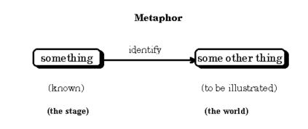
Figure 1. Metaphors in use to map one domain to another (Szabó, 1995).

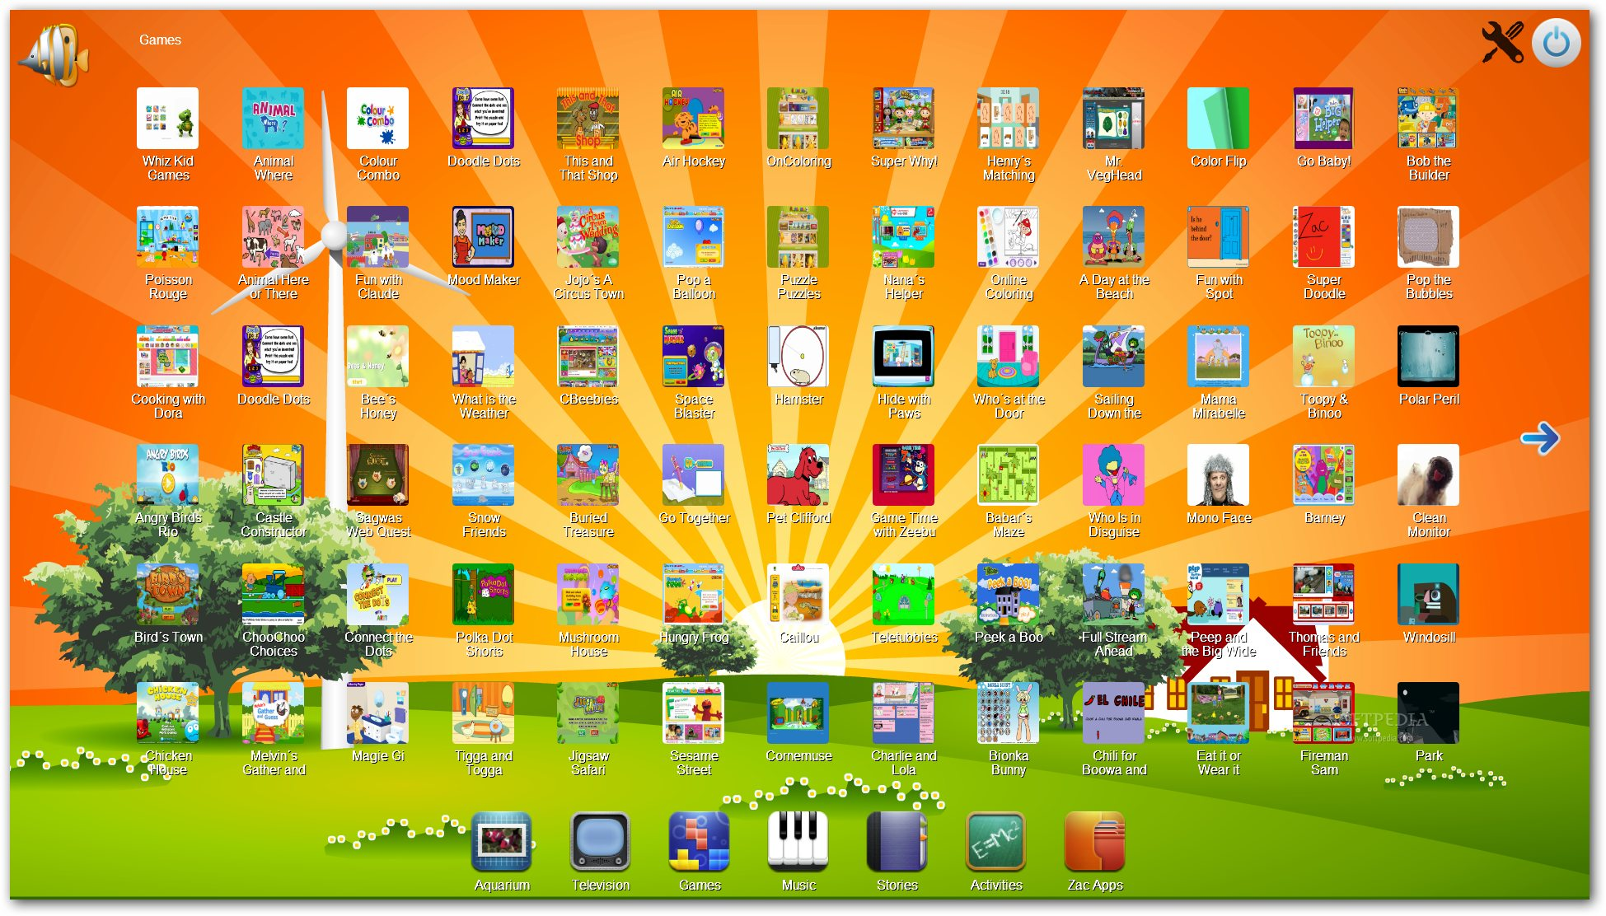
Figure 2. Use of metaphors in Zone for Autistic Children website (https://www.google.com/search?q=ZAC+browser&rlz=1C1CHWA_enUS629US629&espv=2&biw=2182&bih=1095&source=lnms&tbm=isch&sa=X&ved=0CAcQ_AUoAmoVChMItvOk-Iv3yAIVBN1jCh29Zw1j#imgrc=MIZBvn5uQwJNVM%3A)


Figure 3. Use of metaphors in iBooks app
(https://www.google.com/search?q=ZAC+browser&rlz=1C1CHWA_enUS629US629&espv=2&biw=2182&bih=1095&source=lnms&tbm=isch&sa=X&ved=0CAcQ_AUoAmoVChMItvOk-Iv3yAIVBN1jCh29Zw1j#tbm=isch&q=ibooks+app&imgrc=e3d0ZHuFOPJNZM%3A)

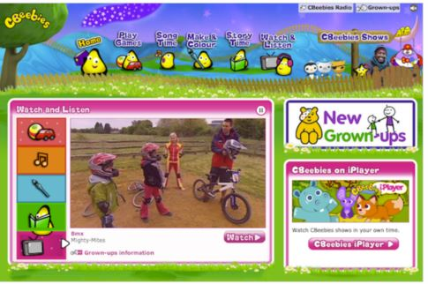

Figure 4. Use of metaphors in BBBC’s CBeebies homepage
(https://www.google.com/search?q=ZAC+browser&rlz=1C1CHWA_enUS629US629&espv=2&biw=2182&bih=1095&source=lnms&tbm=isch&sa=X&ved=0CAcQ_AUoAmoVChMItvOk-Iv3yAIVBN1jCh29Zw1j#tbm=isch&q=BBBC%E2%80%99s+CBeebies+homepage)

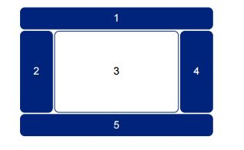
Figure 5. Simple Website Layout (Lanquetin, 2007).

Figure 6. Facebook Homepage metaphors

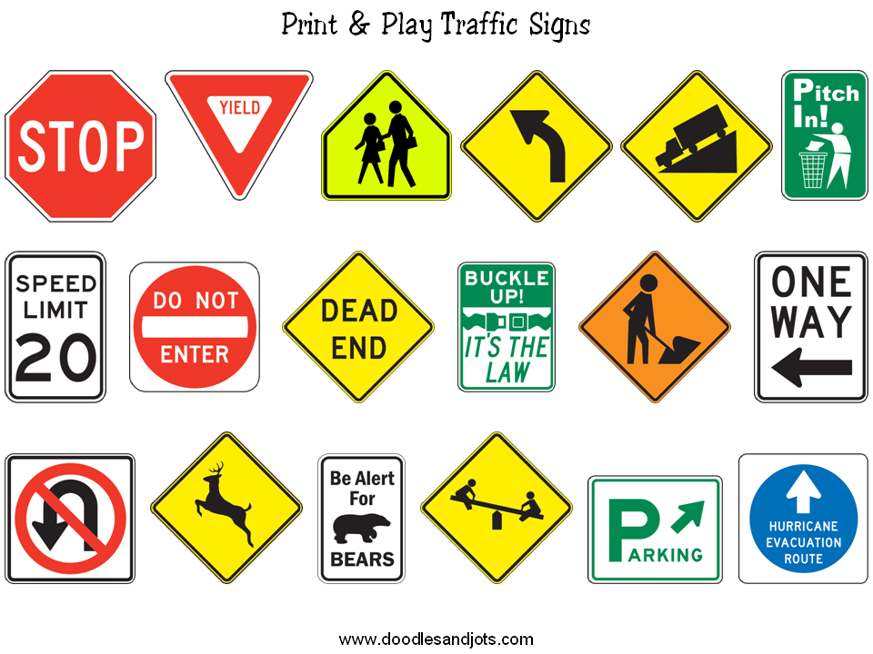
Figure 7. Use of metaphors in Traffic signals
(https://www.google.com/search?q=traffic+signals&rlz=1C1CHWA_enUS629US629&espv=2&biw=2182&bih=1095&source=lnms&tbm=isch&sa=X&ved=0CAYQ_AUoAWoVChMI28DftY_3yAIVi6YeCh1rWQbO#imgrc=WGW92cE9qFCN0M%3A)

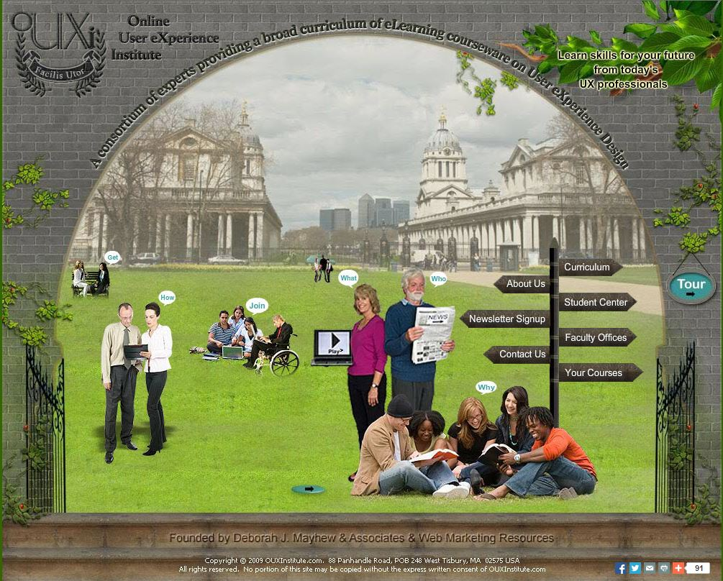

Figure 8. Overuse of metaphors (global metaphor)
(http://www.ouxinstitute.com/)



Figure 9. Confusing use of metaphors in Nexus 5 Homepage

